

NOTICE

[Physical verification]

All the candidates who took admission to Semester-I (B.A. Major) at Onda Thana Mahavidyalaya in the Academic Session 2024-25 are asked to turn up at the college on the stipulated date according to the following schedule for physical verification.

|  |  |  |
| --- | --- | --- |
| **Stream** | **Subject** | **Date&Time** |
| B.A.(Major) | Political Science Major, Physical Education Major and Sanskrit Major | 02/08/2024from12noon. |
| B.A.(Major) | Bengali Major, English Major | 03/08/2024from12noon |
| B.A.(Major) | Geography Major, Education Major and History Major ,Philosophy Major, | 05/08/202412noon |
| B.A.(Major) | All remaining candidates | 06/08/2024from12noon |

All students areadvised to bring the original and self-attested photo copies of the following documents-

1. Two copies of colour Pass port size photographs
2. Aadhar Card
3. Birth Certificate/M.P. admit card
4. M.P.passed marksheet
5. H.S. (10+2)Marksheet
6. Caste certificate, (if any)
7. EWS Certificate (if any)
8. Print out of admission receipt
9. Print out of application form
10. 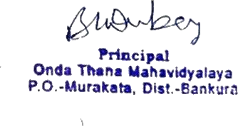School leaving certificate
11. Bank Pass book front page (Photocopy)